REVIVAL

Scottish Charity NoSC017934

Annual Report & Financial Statements

For the Year Ended 31 March 2020

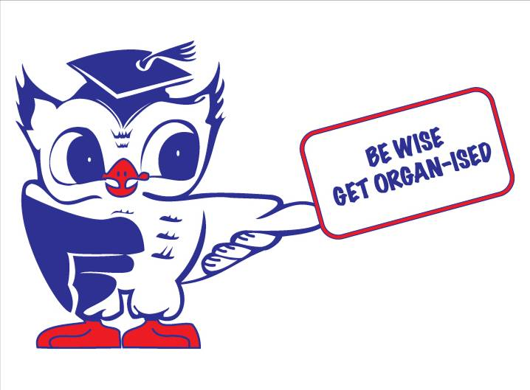

Trustees Annual Report

For the Year ended 31 March 2020

The trustees have pleasure in presenting their report together with the financial statements and the independent examiner’s report for the year ended 31 March 2020

Reference & Administrative Information

Charity Name
REVIVAL

Charity No
SCO17934

Address
c/o Alex Stephen 1 Golpsie Terrace Dundee DD5 2PW

Current Trustees

Sid Grant Chair
Alex Stephen Treasurer
Jenny Park Secretary
Dr Iain Henderson
Graham Matthew
Margaret Gillies
Judy McLellan
Andrew Wilson
Alan Latto
Jane Begg
Carol Bushby
Michael Dun
Raymond Tait

Other Trustees who served during the year

Structure Governance & Management

Constitution
The Charity was established in July 1991 through a Deed of Trust at the same time the Trust was granted charitable status by the Inland Revenue.

Appointment of Trustees
The management committee which normally meets on a monthly basis are the charity’s trustees. Membership of the management committee is open to transplant patients, renal unit patients and family members. Trustees are appointed at the Annual General Meeting which is normally held in June. Under the trust deed at least 50% of the trustees plus one must be in attendance for the meeting to be quorate.

Management
The trustees are responsible for the strategic direction and governance of the charity. There are no paid employees.

Objectives & Activities

Charitable purposes
To advance the health of the public and to relieve those suffering from illness or disease by promoting and providing for a) public awareness of organ retrieval and the benefits of transplantation surgery and b) the creation of an organ donor register and c) the support of patients who have received a transplant or waiting for a transplant.

Activities
Our main activities are in the promotion of the Organ Donor Register, promoting the benefits of transplant surgery and organising the Tayside and North Fife team participating in the National Transplant Games. We also provide support to patients from the Renal Unit

Achievements & Performance
During the year we have attended a number of events to encourage the public to sign up to the Organ Donor Register.

REVIVAL assisted in the organisation of a conference for Renal Unit Patients.

The main achievement during the year was to support National Transplant Week. We look forward to the Scottish Governments proposals for a soft opt out system of organ donation being introduced.

Financial Review
Our main source of funding is donations from the public and fund raising activities.
Our main expenditure each year is in respect of promotional material for our campaigns.
Receipts on the unrestricted fund were £176 (2019 £1048). Payments for the year were £1335 (2019 £1249) The deficit for the year was £1159 (deficit for 2019 £201) and was taken from reserves.

Reserves Policy
The trustees` policy is to maintain reserves sufficient to cover major campaigning activities and to cover the costs of entry to UK Transplant Games. At this point in time the reserve funds are sufficient for these purposes.

Plans for Future Periods
Our plans for the future are to continue to promote the Organ Donor Register, monitor the progress of the “opt out” organ donation system in Wales and take part in consultations on the proposed soft opt out system of organ donation in Scotland. We also hope to enter a team for the 2020 Transplant Games

The Trustees Annual Report was approved by the Trustees on 17 August 2020 and signed on their behalf by:-

Sid Grant
Chair

Independent Examiner’s Report

For the Year Ender 31 March 2020

Independent Examiner’s Report to the Trustees of REVIVAL
I report on the financial statements of the charity for the year ended 31 March 2020 which are set out on pages 6 to 7

Respective responsibilities of Trustees and Examiner
The charity’s trustees are responsible for the preparation of the accounts in accordance with the terms of the Charities and Trustee Investment (Scotland) Act 2005 (“the 2005 Act”) and the Charities Accounts (Scotland) Regulations 2006 (as amended) (“the 2006 Regulations”). The charity’s trustees consider that the audit requirement of Regulation 10 (1)(d) of the 2006 Regulations does not apply. It is my responsibility to examine the accounts as required under section (44)(1)(c) of the 2005 Act and to state whether particular matters have come to my attention.

Basis of Independent Examiner’s Statement
My examination is carried out in accordance with Regulation 11 of the 2006 Regulations. An examination includes a review of the accounting records kept by the charity and a comparison of the accounts presented with those records. It also includes consideration of any unusual items or disclosures in the accounts and seeks explanations from the trustees concerning any such matters. The procedures undertaken do not provide all the evidence that would be required in an audit and, consequently, I do not express an audit opinion on the view given by the accounts.

Independent Examiner’s Statement
In connection with any examination, no matter has come to my attention:-

1. which gives me reasonable cause to believe that, in any material respect the requirements

- to keep accounting records in accordance with section 44(1)(a) of the 2005 Act and Regulation 4 of the 2006 Regulations, and

- to prepare accounts which accord with the accounting records and comply with Regulation 9 of the 2006 Regulations have not been met, or

2. to which, in my opinion attention should be drawn in order to enable a proper
Understanding of the accounts to be reached

Date 17/08/2020

John McDougall, CA
6 Invermark Terrace
Barnhill
Dundee
DD5 2QU

REVIVAL

Statement of Receipts and Payments for the year ended 31 March 2020

Receipts Total Total
2020 2019 £ £
Interest on Investments 176 132
Donations - 916
176 1048

Payments

Promotional Materials 1234 1010 Other Expenses - 138
Insurance 101 101
Total Payments 1335 1249

Surplus (Deficit) for the year (1159) (201)
176 1048

Statement of Balances – as at 31 March 2020

Funds Reconciliation Total Total
2020 2019
£ £
Cash at Bank 31/3/2019 28257 28458
Surplus (Deficit) for year (1159) (201)
Cash at Bank 31/3/2020 27098 28257

Bank and Cash Balances 3463 4798
Deposit Account 23635 23459
27098 28257

All funds are unrestricted
The notes on Page 8 are an integral part of these accounts
Approved by the trustees on 17/08/2020 and signed on their behalf by:-

Sid Grant Alex Stephen
Chair Treasurer

Notes to the Accounts – For the year ended 31 March 2020

1 Basis of Accounting
These accounts have been prepared on the receipts and payments basis in accordance with the Charities and Trustee Investment (Scotland) Regulations 2006 (as amended)

2 Nature and Purpose of Funds
Unrestricted Funds are those that may be used at the discretion of the trustees in performance of the objects of the charity.

3 No Remuneration or expenses were paid to any trustee

